SQL 201 ASSIGNMENT 101

1. For different category of acquirers, what is the average number of months since the inception of the acquired company after which they are acquired.​

SELECT

acquisitions.acquirer_category_code,

(

AVG(

ROUND(

cast(acquisitions.acquired_at_cleaned AS date) - cast(companies.founded_at_clean AS date)

) / 30

)

)

FROM

tutorial.crunchbase_companies_clean_date AS companies

LEFT JOIN tutorial.crunchbase_acquisitions_clean_date AS acquisitions ON companies.permalink = acquisitions.company_permalink

GROUP BY

acquisitions.acquirer_category_code

ORDER BY

acquisitions.acquirer_category_code;

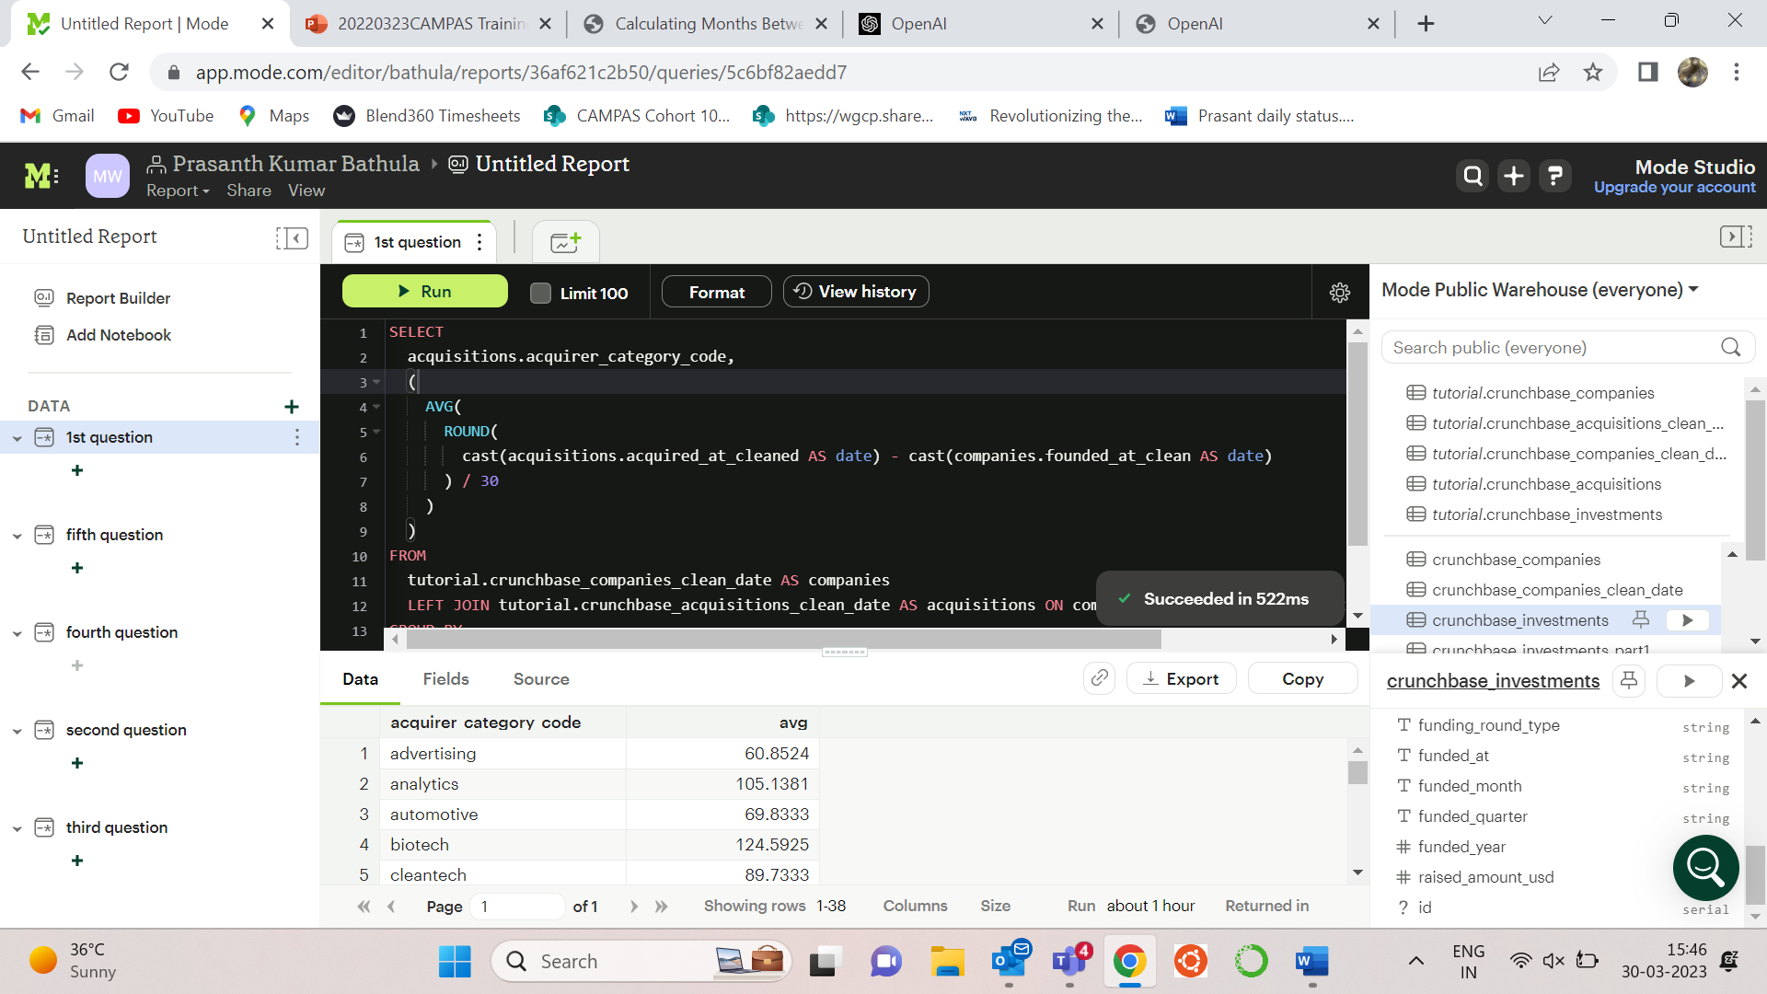

2)Is there any trend for quarters when more companies are acquired ?

SELECT

substring(acquired_quarter, 6, 7) AS quarter,

count(company_name) AS no_of_companies_aquired

FROM

tutorial.crunchbase_acquisitions

GROUP BY

quarter

ORDER BY

no_of_companies_aquired DESC;

3) For each company_category_code identify the average raised_amount_usd per quarter​?

SELECT

company_category_code,

round(

(

SELECT

avg(raised_amount_usd)

FROM

tutorial.crunchbase_investments AS sub1

WHERE

out.company_category_code = sub1.company_category_code

AND substring(funded_quarter, 6, 7) = 'Q1'

)

) AS quarter_1,

round(

(

SELECT

avg(raised_amount_usd)

FROM

tutorial.crunchbase_investments AS sub1

WHERE

out.company_category_code = sub1.company_category_code

AND substring(funded_quarter, 6, 7) = 'Q2'

)

) AS quarter_2,

round(

(

SELECT

avg(raised_amount_usd)

FROM

tutorial.crunchbase_investments AS sub1

WHERE

out.company_category_code = sub1.company_category_code

AND substring(funded_quarter, 6, 7) = 'Q3'

)

) AS quarter_3,

round(

(

SELECT

avg(raised_amount_usd)

FROM

tutorial.crunchbase_investments AS sub1

WHERE

out.company_category_code = sub1.company_category_code

AND substring(funded_quarter, 6, 7) = 'Q4'

)

) AS quarter_4

FROM

tutorial.crunchbase_investments AS out

GROUP BY

company_category_code;

4) Which investor is more likely to invest in USA based companies?

SELECT

investor_name,

count(investor_name) AS no_of_investments

FROM

tutorial.crunchbase_investments

WHERE

company_country_code = 'USA'

GROUP BY

investor_name

ORDER BY

no_of_investments DESC

LIMIT 1;

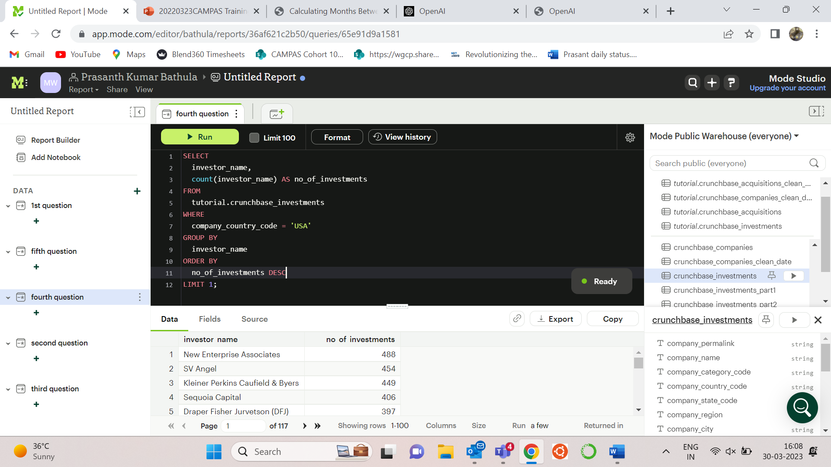

5) For different type of funding rounds, what is the average raised amount per quarter​?

SELECT

funding_round_type,

round(

(

SELECT

avg(raised_amount_usd)

FROM

tutorial.crunchbase_investments AS sub1

WHERE

out. funding_round_type = sub1. funding_round_type

AND substring(funded_quarter, 6, 7) = 'Q1'

)

) AS quarter_1,

round(

(

SELECT

avg(raised_amount_usd)

FROM

tutorial.crunchbase_investments AS sub1

WHERE

out. funding_round_type = sub1. funding_round_type

AND substring(funded_quarter, 6, 7) = 'Q2'

)

) AS quarter_2,

round(

(

SELECT

avg(raised_amount_usd)

FROM

tutorial.crunchbase_investments AS sub1

WHERE

out. funding_round_type = sub1. funding_round_type

AND substring(funded_quarter, 6, 7) = 'Q3'

)

) AS quarter_3,

round(

(

SELECT

avg(raised_amount_usd)

FROM

tutorial.crunchbase_investments AS sub1

WHERE

out. funding_round_type = sub1. funding_round_type

AND substring(funded_quarter, 6, 7) = 'Q4'

)

) AS quarter_4

FROM

tutorial.crunchbase_investments AS out

GROUP BY

funding_round_type;

6) Identify companies that received an investment from Japan following an investment from Great Britain where investor is finance category company​?

SELECT

*

FROM

(

SELECT distinct

company_name,

funded_at,

lead(funded_at) over(

PARTITION by company_name

ORDER BY

funded_at ASC

),

investor_country_code,

lead(investor_country_code) over(PARTITION by company_name) AS next_country

FROM

tutorial.crunchbase_investments

) AS out

WHERE

next_country = 'JPN'

AND investor_country_code = 'GBR';

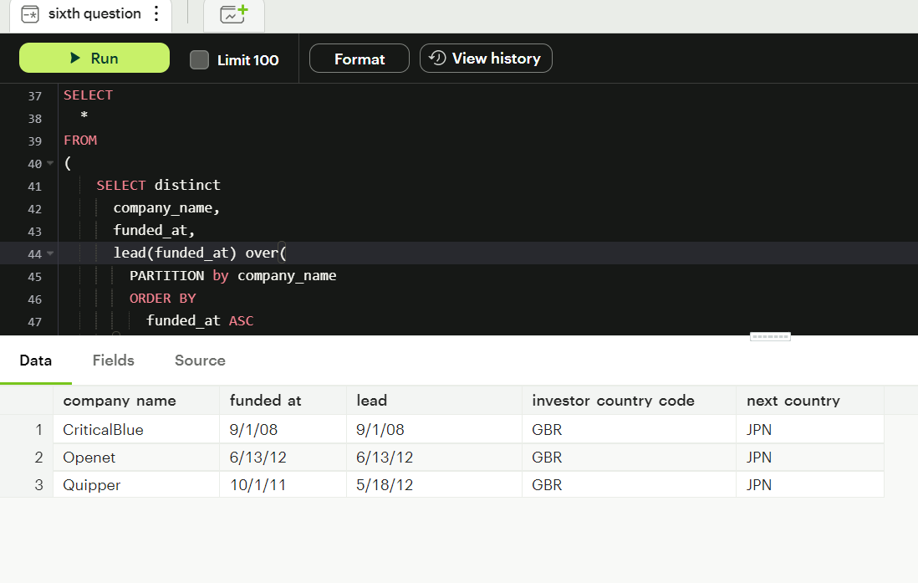

1. Out  of all 'operating' status companies, which category of companies have the highest average funding_total_usd?​

SELECT

category_code,

avg(funding_total_usd) AS avg_funding_total_usd

FROM

tutorial.crunchbase_companies_clean_date

WHERE

STATUS = 'operating'

GROUP BY

category_code

ORDER BY

avg_funding_total_usd DESC

LIMIT

1;

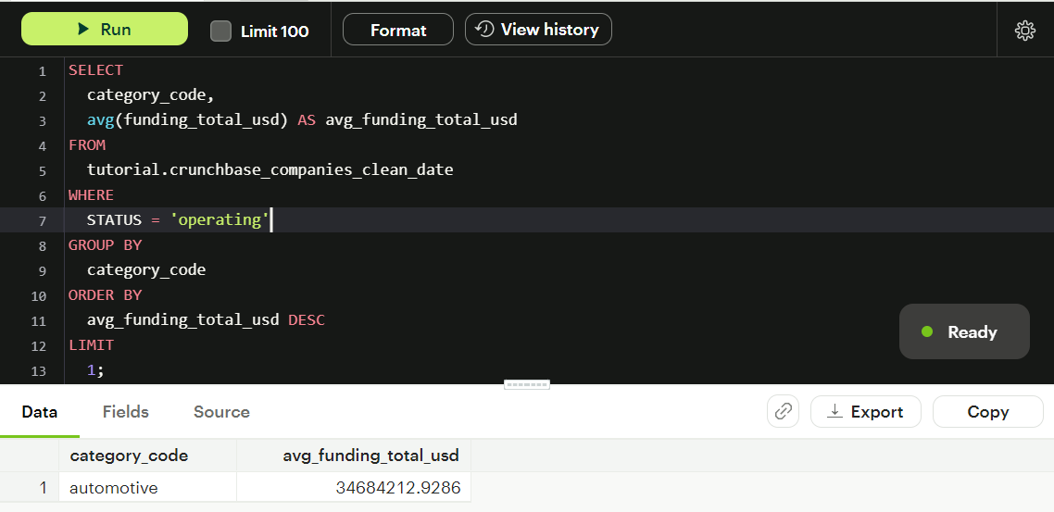

1. For each category, what percent of companies received funding within 3 years of their founding?​

SELECT

category_code,

CASE

WHEN NOT category_code ISNULL THEN (

cast(

(

SELECT

count(DISTINCT name)

FROM

tutorial.crunchbase_companies AS sub

WHERE

sub.category_code = out.category_code

AND (

cast(sub.first_funding_at AS date) - cast(sub.founded_at AS date)

) < 1095

) AS float

) / cast(

(

SELECT

count(DISTINCT name)

FROM

tutorial.crunchbase_companies AS sub

WHERE

out.category_code = sub.category_code

) AS float

)

) * 100

ELSE (cast(

(

SELECT

count(DISTINCT name)

FROM

tutorial.crunchbase_companies AS sub

WHERE

sub.category_code isnull

AND (

cast(sub.first_funding_at AS date) - cast(sub.founded_at AS date)

) < 1095

) AS float

) / cast(

(

SELECT

count(DISTINCT name)

FROM

tutorial.crunchbase_companies AS sub

WHERE

sub.category_code IS NULL

) AS float

)

) * 100

END AS percentage

FROM

tutorial.crunchbase_companies AS out

GROUP BY

category_code;

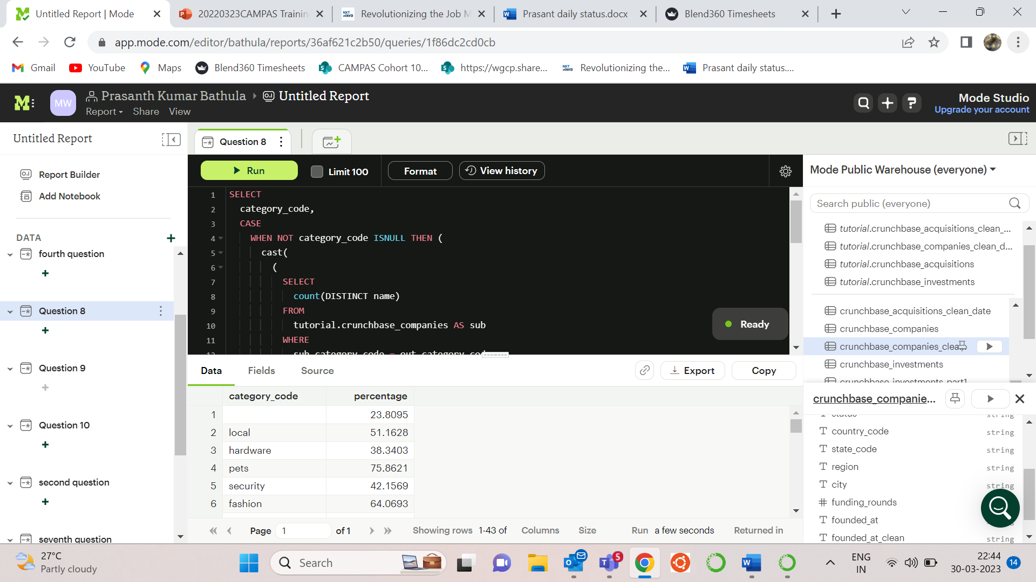

1. Clean the 'last_funding_at' column (convert it to time stamp) and get the time difference with the current time.​

SELECT

cast(last_funding_at AS timestamp),

NOW() - cast(last_funding_at AS timestamp) AS difference_in_days

FROM

tutorial.crunchbase_companies;

